**2024-25**

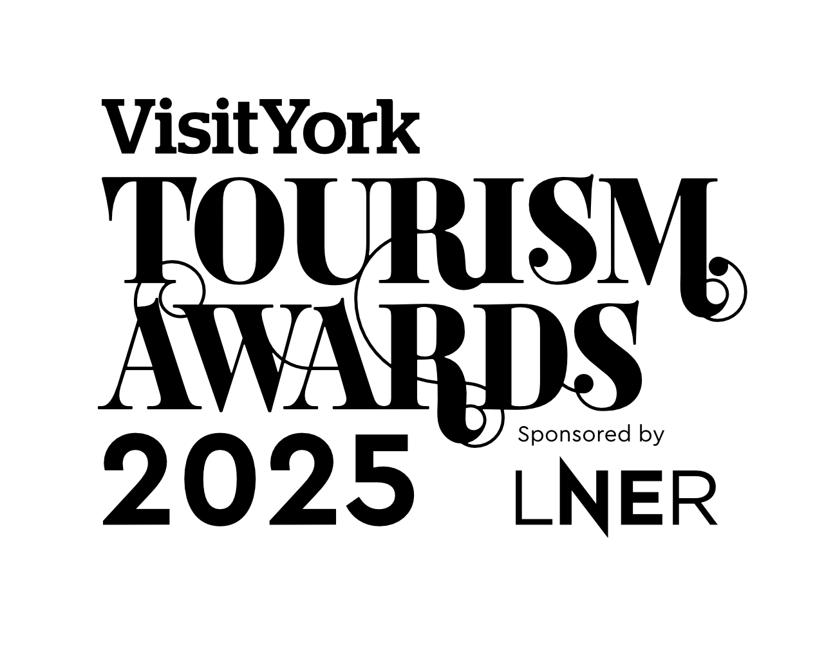

# Event or Festival of The Year (Local Award)

**Recognises organisers of truly memorable and immersive events and festivals for visitors to enjoy.**

**This sample application form is for information only and all applications must be made via the online application system.**

## Eligibility criteria

* Directly involved in culture and/ or tourism, providing a culture rich experience for residents and visitors to enjoy. And/ or making a contribution to the visitor economy with a significant proportion of business generated by people visiting from outside the local area.
* Any event within the culture or tourism sectors is eligible to apply regardless of size/ scale.
* Likely to be immersive and interactive.
* Submissions must be for events must have taken place between October 2023 and August 2024
* This category is judged within the context and style to fit the nature of the category.

## Applicant & Organisation details

(not scored)

**Applicant’s name:**

Enter the applicant’s name here.

**Applicant’s job title:**

Enter the applicant’s job title here.

**Applicant’s phone number:**

Enter the applicant’s phone number here.

**Applicant’s email:**

Enter applicant’s email here.

**Business name:**

Name of business application relates to. Give the name used to promote the business, as you wish it to appear in all publicity materials, on certificates, in presentations etc.:

Enter your business name here.

**Business address:**

Enter your business address here.

Non availability during judging period (the judging period for this category will be an interview with the judging panel and take place October 2022 - November 2022)

Enter closures during the judging period here.

**Name of Event or Festival:**

Enter the name of Event or festival here

**Promotional Description**

Provide a promotional description of your business.

* Focus on its strengths and stand out features
* Write your description with regard to this category
* This wording will be used in PR and awards literature
* Wording provided is subject to edit
* 120 word maximum

Enter the promotional description here.

**Promotional Images**

Provide up to three landscape high resolution photos.

* Photos should relate to this category
* Photos should not be edited in any way e.g. embedded text or logos, a collage
* Only include photos that you own the copyright for
* If the photo requires a credit e.g. photographer, please provide details
* These photos will be used in PR and awards literature

## Background

(not scored)

**Briefly outline the story of your business (250 words maximum).**

For example:

* Length of time business has been trading and time under current ownership
* Target market(s) and typical customer profile
* Key milestones in developing the business
* Indication of size of business
* Number of staff employed, if any

Enter information on the background of your business here.

**List any awards, ratings, accolades and COVID-19 reassurance accreditations received in the last two years. Include the title, awarding body, level and date achieved.**

For example:

* Successes in this competition and the VisitEngland Awards for Excellence
* TripAdvisor Certificate of Excellence
* Green Tourism award
* VisitEngland and/or AA quality assessment, local quality accreditation
* VisitEngland’s ‘We’re Good to Go’; the AA’s ‘COVID-19 Confident’; Quality in Tourism’s ‘Safe clean and legal’

Enter information on any awards, ratings or accolades here.

**There is no requirement for your business to be quality assessed. However, if you have an independent quality assessment/mystery shopping report from the last two years, you might wish to attach it when emailing your completed application form /upload it here (optional).**

## Online presence & reviews

(Scored)

**Provide links to your online presence, which will be reviewed and scored by judges in addition to your answers to the four questions. Other sites may also be checked.**

**Website**

Enter the website URL here.

**Accessibility & inclusivity information** (Provide links to your accessibility and inclusivity information.)

Enter the accessibility & inclusivity information URL here.

**Sustainability information** (Provide links to your sustainability information.)

Enter the sustainability information URL here.

**Social Media Platforms**

Provide links to all business pages/profiles on Facebook, Instagram etc. and Twitter handles

Enter social media platforms here.

**Online review sites**

Provide specific links to customer review listings for your business e.g. TripAdvisor, Facebook, Booking.com, Google, Euan’s Guide, UpFront Reviews

Enter online review sites here.

## Question 1 - Your Top Qualities

(Scored)

**Tell us about up to five ways in which your experience is impressive compared to your competitors (500 words maximum).**

One or more of the following example areas may be relevant to address in your answer (it is not mandatory to cover every area):

* Added extras that delight your customers
* How you care for your team
* Use and promotion of local suppliers, including food & drink offer centred on locally sourced produce
* Innovative marketing and PR, including partnerships with other businesses
* Facilities and welcome for people with a range of accessibility requirements
  + For example, this may include information provision, adapted customer experiences, accessible facilities for people with a range of impairments and staff disability awareness training
* Managing and improving environmental, social and economic impacts
  + For example, this may include a carbon reduction plan, energy and waste monitoring, green transport, community initiatives and responsible purchasing

Enter answer to question 1 here.

Links to relevant supporting evidence online (optional):

You will not be penalised if you have not included supplementary evidence. Any written answers that are included within the supplementary evidence, attempting to circumvent the question word counts, will be disregarded.

Enter links to supplementary evidence here.

## Question 2 - Your Recent Improvements

(Scored)

**Tell us about up to five ways in which you have developed your experience and/or improved the customer experience over the last two years (500 words maximum).**

One or more of the following example areas may be relevant to address in your answer (it is not mandatory to cover every area):

(Only include examples of improvements undertaken in the last two years.)

* Promotional initiatives e.g. new website
* Improving the skills of you and your team
* Expansion, upgrade of facilities, enhancements to your services
* Facilities and welcome for people with a range of accessibility requirements
* For example, this may include information provision, adapted customer experiences, accessible facilities for people with a range of impairments and staff disability awareness training
* Managing and improving environmental, social and economic impacts
* For example, this may include a carbon reduction plan, energy and waste monitoring, green transport, community initiatives and responsible purchasing
* Reasons for making the improvements e.g. driven by customer feedback
* Approximate date of improvement

Enter answer to question 2 here.

Links to relevant supporting evidence online (optional):

You will not be penalised if you have not included supplementary evidence. Any written answers that are included within the supplementary evidence, attempting to circumvent the question word counts, will be disregarded.

Enter links to supplementary evidence here.

## Question 3 - Your Results

(Scored)

**Tell us about three successes from the last year, providing figures where relevant (300 words maximum).**

One or more of the following example areas may be relevant to address in your answer (it is not mandatory to cover every area):

* Whether you are able to attribute success directly to any of the improvements that you’ve made (mentioned in Question 2)
* Percentage increase in occupancy levels/visitor numbers, sales, customer satisfaction and wastage reduction
* Percentage increase in online bookings
* Increase in repeat business
* Business generated from marketing activity
* Growth of social media following and engagement
* The significance of the level of impact on your business

Enter answer to question 3 here.

Links to relevant supporting evidence online (optional):

You will not be penalised if you have not included supplementary evidence. Any written answers that are included within the supplementary evidence, attempting to circumvent the question word counts, will be disregarded.

Enter links to supplementary evidence here.

## Question 4 – Your Future Plans

(Scored)

**Tell us about three ways you will develop and promote your experience over the next year and the reasons why (300 words maximum).**

One or more of the following example areas may be relevant to address in your answer (it is not mandatory to cover every area):

* Continued adaption, diversification and resilience building as a result of the COVID-19 pandemic
* Facilities and welcome for people with a range of accessibility requirements
* For example, this may include information provision, adapted customer experiences, accessible facilities for people with a range of impairments and staff disability awareness training
* Managing and improving environmental, social and economic impacts
* For example, this may include a carbon reduction plan, energy and waste monitoring, green transport, community initiatives and responsible purchasing
* Expansion, upgrade of facilities, enhancements to your services
* Improving the skills of you and your team
* Marketing and PR, including partnerships with other businesses
* Operational efficiency

Enter answer to question 4 here.

Links to relevant supporting evidence online (optional):

You will not be penalised if you have not included supplementary evidence. Any written answers that are included within the supplementary evidence, attempting to circumvent the question word counts, will be disregarded.

Enter links to supplementary evidence here.